**Exercise 3: Sorting Customer Orders**

**Understand Sorting Algorithms**

1. **Bubble Sort**

* Compares and swaps adjacent items until the list is sorted.
* Simple to implement but becomes very slow as the list grows.

1. **Insertion Sort**

* Builds the final sorted list by placing each item in its correct position.
* Works well for small or mostly sorted data but is slow for large lists.

1. **Quick Sort**

* Picks a pivot and organizes items around it using divide-and-conquer.
* Very fast in most cases and widely used in real applications.

1. **Merge Sort**

* Splits the list, sorts each part, and merges them together.
* Gives reliable performance and handles large lists well.

**Output**

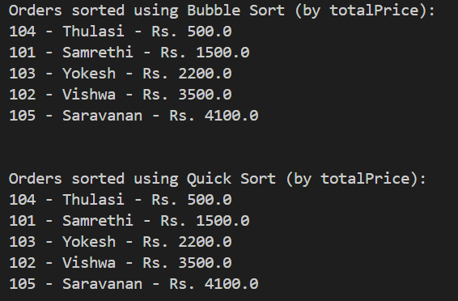

**Time Complexity Comparison**

* Bubble Sort is slow overall, especially for big lists.
* Quick Sort is much faster and more efficient in general cases.

**Why Quick Sort is Preferred**

* Handles large data better due to faster sorting.
* More practical and widely used compared to basic sorting methods.